AGENDA
Not Only Dressed but Dressing
Clothing, Childhood, Creativity

Workshop 2: Agency and Control

Creative Studio, V&A Museum, Cromwell Rd, London SW7 2RL

Microsoft Teams link TBC

Wednesday 8 June 2022

9.40 a.m. Group meet at the V&A’s Secretariat Entrance on Cromwell Road

10.00 a.m. Coffee

10.15 a.m. Welcome from organizers

10.45 a.m. First panel
Julie Blanchard-Emmerson (UCA)
Annamari Vänskä (Aalto)
Nuno Ferreira and Maria Moscati (Sussex)

12.15 p.m. Lunch

1.15 p.m. Second panel
Ben Hinson (V&A)
Clare Rose

2.15 p.m. Collection spotlight on sustainability with Katy Canales (Young V&A) and Ryan Mario Yasin (Petit Pli)

3.15 p.m. Coffee

3.30 p.m. Third panel—remote presentations
Jennifer Farley Gordon (Iowa State)
Jane Pilcher (Nottingham Trent)

4.30 p.m. Discussion

5.30 p.m. Workshop end

6.00 p.m. Workshop dinner
Ognisko, 55 Prince’s Gate, Exhibition Road,
London SW7 2PG

Workshop Information

Organizers

Hannah Field (Sussex) and Kiera Vaclavik (Queen Mary)

Museum Representative

Katy Canales (Young V&A)

Network Administrator

Juliette Milbach (School of Advanced Study, University of London)

Discussion Questions

- How can we best map power dynamics, from imposition to contestation/rejection via collaboration, between children and adults in relation to dress?
- How are these dynamics specific to different modes of dress, e.g., uniform?
- How do these dynamics inflect understandings of childhood and of fashion?
- What research methods can uncover intergenerational relations, including in past eras?
- How do the answers to these questions depend on children’s social and cultural backgrounds, gender identities, and other factors?

On the Day

COVID Precautions

We ask that all in-person participants are double vaccinated and take a lateral flow test on the morning of the workshop. We also ask that participants are masked throughout the day, except when eating or presenting.

Museum Access

Presenters and participants external to the V&A need to collect passes and enter at the Secretariat Gate (see map below). Katy Canales will meet us there at 9.40 a.m., and her mobile number in case of any problems is 07881622797.

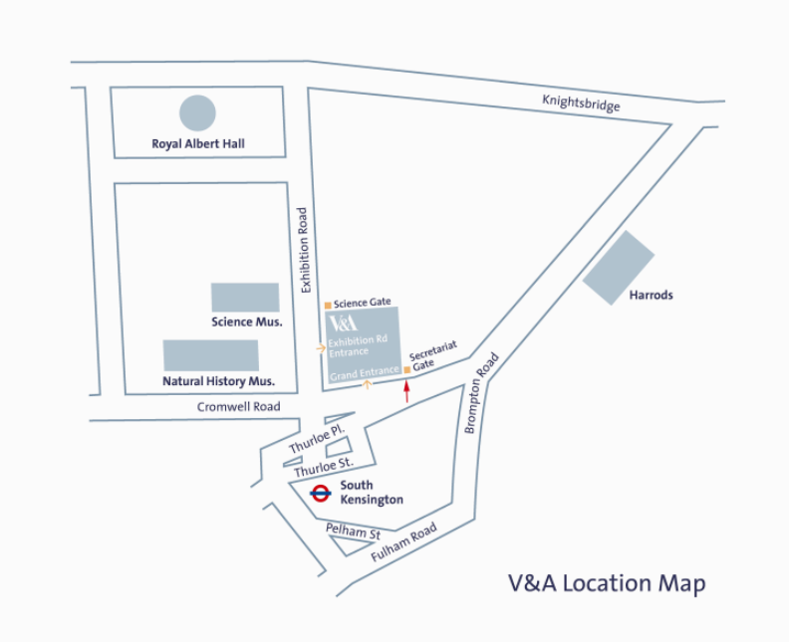

Abstracts

Julie Blanchard-Emmerson
Materializing Identities: Pre-Teen Girls Negotiating Femininity, Family, and the Future through Fashion

Building on research with predominantly white, middle-class, British girls aged between eight and eleven years old, this presentation explores how clothes are used in their creation of identity. What to wear is negotiated between parents and children but also between peers and enables the display of both kinship and friendship. Depending on social context, girls constructed multiple, fluid identities through dress, whilst the materiality of clothing allowed access to their past and imagined future, helping girls situate themselves in the present.

Dr Blanchard-Emmerson is a senior lecturer in fashion histories and theories at the University for the Creative Arts, teaching about the relationship between the body, identity, materiality, and dress. Her article ‘Feeling Time, Fashioning Age: Pre-teen Girls Negotiating Life Course and the Ageing Process through Dress’ was published in Sociology in 2021.

Jennifer Farley Gordon
Power Dynamics in the Mid-Twentieth-Century Children’s Wear Industry

Before an item of clothing appears in a store, countless design and production decisions have already been made. Within the modern children’s wear industry, designers and company executives have had varying degrees of power to control how children are dressed. This research examines power dynamics in children’s wear from an industry perspective, focusing on select mid-twentieth century designers and companies, and asks: how do a designer’s philosophies on dressing children, or a company’s marketing strategies, influence the marketplace and the consumption of children’s clothing? The study explores the rise of the designer name in the marketing of children’s wear, as well as the prolific use of design and marketing gimmicks to drive sales of children’s clothing, during a period in which it is often unclear whether parent or child is the targeted consumer.

Dr Gordon is a lecturer in apparel, merchandising, and design at Iowa State University and the digital curator for the university’s Textiles and Clothing Museum. She teaches courses in the history of fashion and conducts research on the history of the children’s wear industry. She previously worked as an assistant curator at the museum at the Fashion Institute of Technology.

Ben Hinson
Apotropaic and Protective Decoration on Children’s Garments from Late Antique Egypt in the V&A

Late Antique and early Islamic Egyptian tunics were highly decorated. However, decoration is rarely just aesthetic, but encodes cultural, religious, or personal meaning. This paper will discuss fragments of children’s garments from Egypt in the V&A dated between the 4th to 8th Centuries, and specifically their decoration, to explore questions of adult agency. It will explore how, whilst children’s decoration was largely part of the same artistic world as that of adult garments, the specific selection of motifs and images focussed primarily on concerns of protection and wellbeing, reflecting parental and societal pre-occupations with child mortality.

An assistant curator in the Asian Department at the V&A (Middle East section), Dr Hinson is an expert in the archaeology of childhood. His doctoral thesis at the University of Cambridge focused on childhood in New Kingdom Egypt.

Maria Moscati and Nuno Ferreira
Children, Dress Codes, and the Politics of Identity

School-age children increasingly find themselves embroiled in protracted conflicts and power struggles over dress codes around the world. While facing the need to respect school uniform rules, children—along with their families and communities—also wish to ensure that they are true to their religious, ethnic, gender identities, and political and philosophical beliefs. Against this background, tensions ensue over the length of skirts, hairstyles, wearing skirts or trousers, and being allowed to wear various items not foreseen by school uniform guidance. This presentation will explore some of these issues, drawing from examples around the world. Building on the case of Shabina Begum—the teenager who insisted on wearing a particular Islamic dress and took her case against her school to the UK Supreme Court in 2006—we will explore empirical data, scholarly work, and media pieces to explore several contexts in which children’s identities become political and are politicized by several social actors.

Dr Moscati is senior lecturer in family law at the University of Sussex. Her current research includes a funded project by the Socio-Legal Studies Association, which investigates the voices of trans young people in England concerning reforms to the Gender Recognition Act 2004.

Nuno Ferreira joined the University of Sussex as a professor of law in 2016. He led the Horizon 2020 European Research Council Starting Grant project Sexual Orientation and Gender Identity Claims of Asylum (SOGICA).

Jane Pilcher
Not Only Determined but Determining? Understanding Children, Clothing, and Control

In my talk, I draw on my earlier work which argued that children are exceptional consumers: what children come to wear on their bodies is subject to a similar, but always different, set of social processes than is the case for adults. I propose that children’s consumption of clothing can usefully be understood through the concept of ‘determinativity’, whereby different social and cultural processes operate together at four levels to determine children’s consumption of clothing. These are ‘discourses of childhood’, the ‘production-market’, ‘the life world’, and ‘me-making’. Thinking about power, children, and clothing using this framework encourages recognition of children as actors who are engaged in fashion consumption practices in order to conceptualize and realize who they are, who they have been and who they want to be, albeit under circumstances not of their own choosing or control.

In her research Dr Pilcher, associate professor of sociology at Nottingham Trent University, often considers the sociocultural significance of children as consuming agents of clothing fashions, as well as girls, clothing, and the sexualization of childhood.

Clare Rose
Motherhood and Vicarious Consumption in Britain, 1880–1914

This paper will examine the role of mothers in providing children’s clothing in Britain from 1880 to 1914, in a society which was both fixated on consumption as a sign of social status and concerned about correct methods of mothering. It will give an overview of texts addressed to middle-class and working-class mothers to show how maternal provision of clothing was conceptualized for different social levels. Children’s attitudes to clothing in nineteenth century autobiographies will also be considered. The extent to which clothing practices reflected these texts will be evaluated through quantitative analysis of school group photographs. This innovative methodology provides a way of accessing the lived experience of children who left no written record, and of evaluating the veracity of autobiographies.

Dr Rose has over twenty years of experience as a historian of fashion, textiles, and childhood. Her ground-breaking book Making, Selling, and Wearing Boys’ Clothes in Late-Victorian England was published by Routledge in 2010.

Annamari Vänskä (Aalto University)
It’s a Cool Game! Children, Wearable Technology, and Gamification

Since the emergence of children’s consumer culture in the latter part of the twentieth century, Finnish children have been dressed in functional wear—boots, overalls, rainwear, and so forth—which has become commonly considered as the sign of healthy, proper, and ideal childhood, and a sign that sets Finnish childhood apart from, for example, Central European childhood. The grand narrative of Finnish childhood has made it clear that a child is ideally brisk, playful, and outdoorsy, and that the clothes children wear must therefore be comfortable, practical, and endure heavy wear. Simultaneously, research has also shown that children spend less time outdoors and that healthy lifestyles are not the norm anymore. For example, in recent decades, obesity in children and young people has increased both in Finland and elsewhere. To ‘fix the problem’, parents are offered wearable technology solutions with which to monitor children’s daily activities and which are designed to imitate play. These devices are marketed as playful aids to ‘help kids enjoy an active childhood while making every day easier for parents’.

This paper discusses the changing landscape of childhood in Finland and how it is reflected in the clothes children wear. The paper also invites a broader discussion about childhood: how changing urban and indoors-centred lifestyles affect children, what kinds of clothes and technological solutions children are offered, and what new issues and concerns may rise from these, for example, children’s tracking and monitoring. What new approaches in terms of research and design are needed and what new topics should be addressed, when new technologies designed to track and monitor individuals are offered to minors in the name of staying healthy?

Dr Annamari Vänskä is professor of fashion research in the Department of Design at Aalto. She currently leads the research project ‘Intimacy, Creative Work, and Design’, funded by the Strategic Research Council at the Academy of Finland. Vänskä’s research focuses on fashion and visual culture, particularly on mediatization of fashion, fashion and queer theory, and fashion curating. Her book Fashionable Childhood: Children in Fashion Advertising (2017) is the first to examine representations of children in fashion media.

Other Delegates in Attendance

Tamsin Ace, Head of Cultural Programming, London College of Fashion
Susan North, Curator of Fashion, 1550–1800, V&A
Ryan Mario Yasin, Founder and CEO, Petit Pli

Filming

Paul Shammasian, Solascope Pictures

